CONTEXTGUARD

1. Website structure
Main application
The authenticated workspace experience
01
Overview
Dashboard, metrics, activity, urgent conflicts
02
Documents
Wiki library, document details, version history
03
Contradictions
Detected conflicts, filters, evidence comparison
04
Resolution Center
AI-generated drafts, review, approval
05
Slack Monitor
Live alerts, message simulator, alert history
06
Analytics
Trends, detection accuracy, resolution time
07
Settings
Workspace, integrations, policies, permissions
For the hackathon, build all seven as navigation destinations, but fully implement the first five. Analytics and Settings can start with smaller, functional versions.

2. Global application layout

ContextGuard
Knowledge Intelligence
WORKSPACE
Overview
Documents
Contradictions
Resolution Center
Slack Monitor
Analytics
Settings
Knowledge health

Needs attention
3 open contradictions require review.
Illustrative wireframe of the navigation and sidebar. On desktop, use a fixed left sidebar and a flexible main content area; on mobile, collapse navigation into a menu.
Global elements on every page
- Workspace switcher and user profile.
- Left sidebar navigation.
- Search across documents and contradictions.
- Notification center for newly detected issues.
- Primary action button, such as “Add document” or “Analyze.”
- Breadcrumbs on nested pages.
- Consistent severity indicators: Critical, High, Medium, Low.
- Loading, empty, error, and success states.
- Clear source citations wherever AI makes a claim.

Page 1
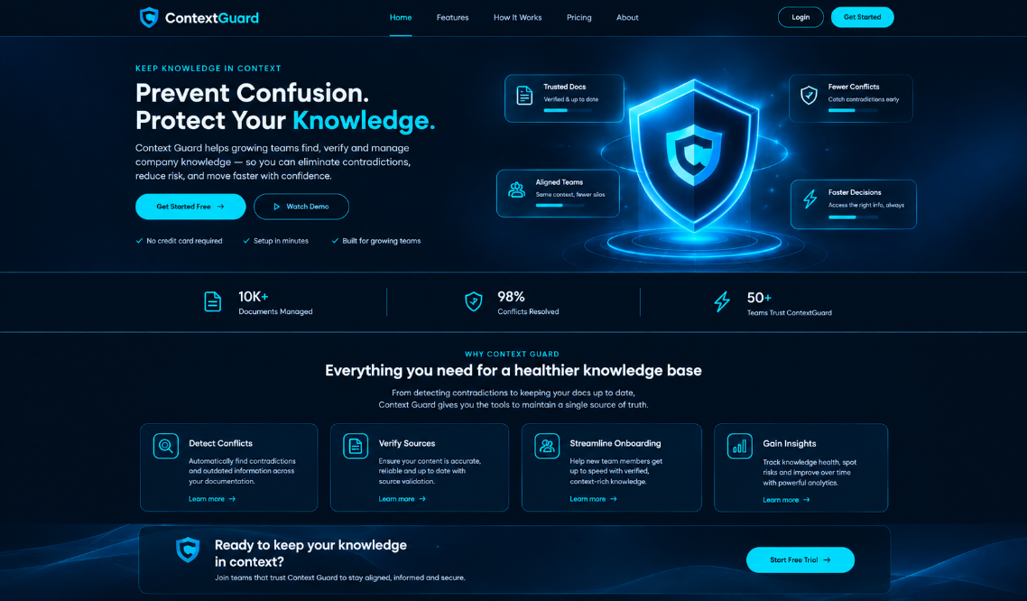
Overview dashboard
Route: /dashboard
Purpose: Let a manager understand the company's knowledge health within five seconds.
Features
- KPI cards: total documents, open contradictions, resolved conflicts, Slack alerts.
- Priority issue list with severity and direct links.
- Recent activity feed.
- Knowledge health summary.
- Documents needing review.
- Quick actions: Add document, Analyze documents, View conflicts.
- Detection status: last scan time and indexing failures.
- Filter by team, document category, and date range.
- Empty state for a workspace with no documents.
- A visible demo-workspace indicator.
Key interactions: Clicking a metric opens its filtered list. Clicking an issue opens the contradiction detail page. Clicking “Analyze documents” runs the detection workflow.

Page 2
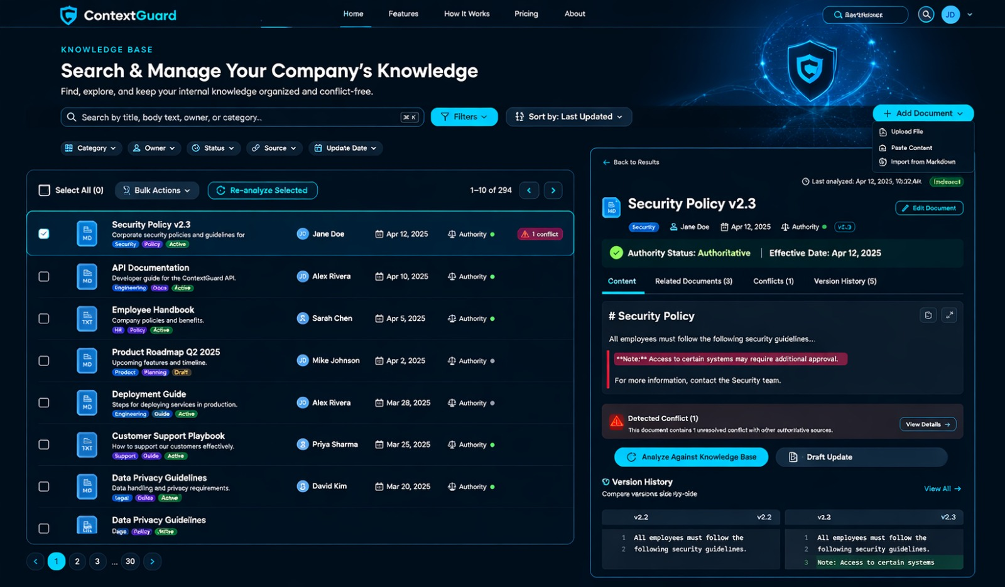
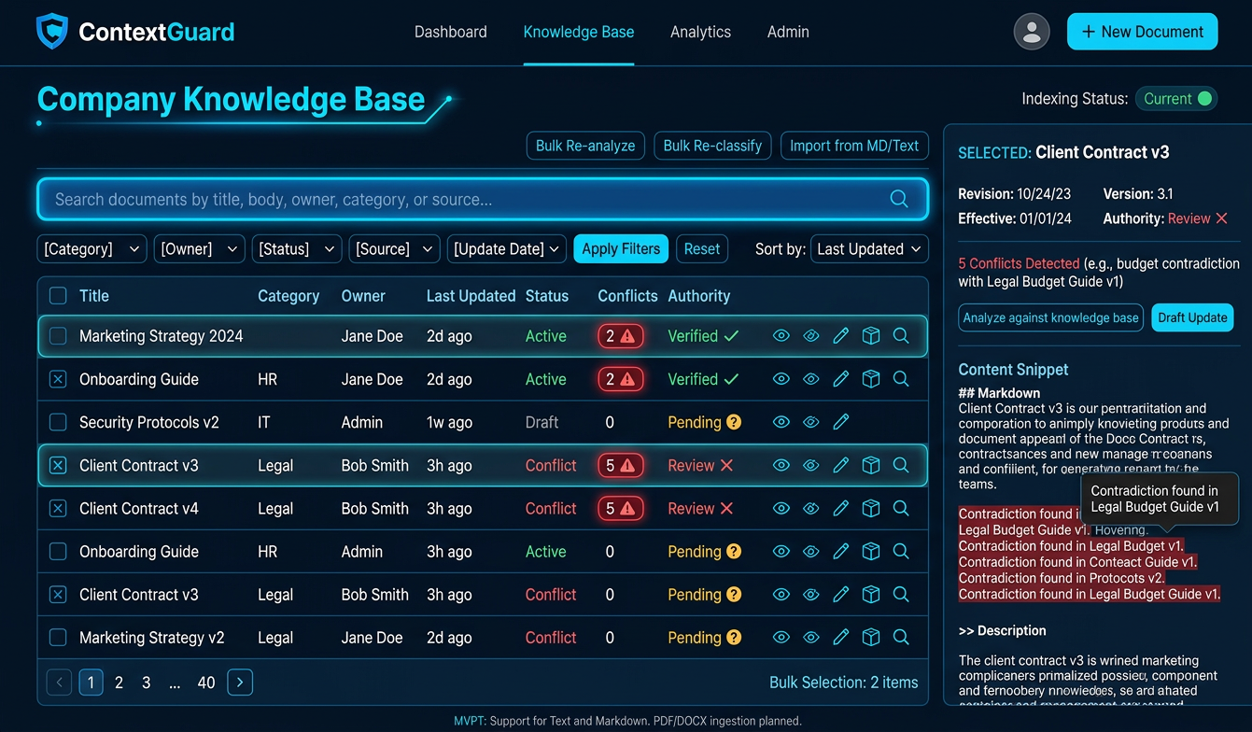
Purpose: Make the company's internal knowledge searchable and manageable.

Features
- Search by title, body text, owner, and category.
- Filters for category, owner, status, source, and update date.
- Sort by last updated, title, conflict count, or authority.
- Add, edit, archive, and view documents.
- Upload or paste document content.
- Import from Markdown or text files for the MVP.
- Show document owner, revision date, version, and authority status.
- Conflict indicators on documents with unresolved issues.
- Pagination or virtualized lists when the corpus grows.
- Bulk selection and re-analysis.
- Document preview with highlighted conflicting excerpts.

Document detail page
Route: /documents/[id]
Include:
- Document title and metadata.
- Readable content viewer.
- Edit document action.
- Authority status and effective date.
- Related documents.
- Detected conflicts within the document.
- Version history with a side-by-side diff.
- Last analyzed time and indexing status.
- “Analyze against knowledge base” action.
- “Draft update” action when a contradiction is found.
Add Document modal fields: title, category, owner, content, source URL (optional), version, effective date, authority status, and file upload.
For the MVP, support text and Markdown first. PDF and DOCX ingestion can be a later enhancement.

Page 3

Page 3 — Contradictions center
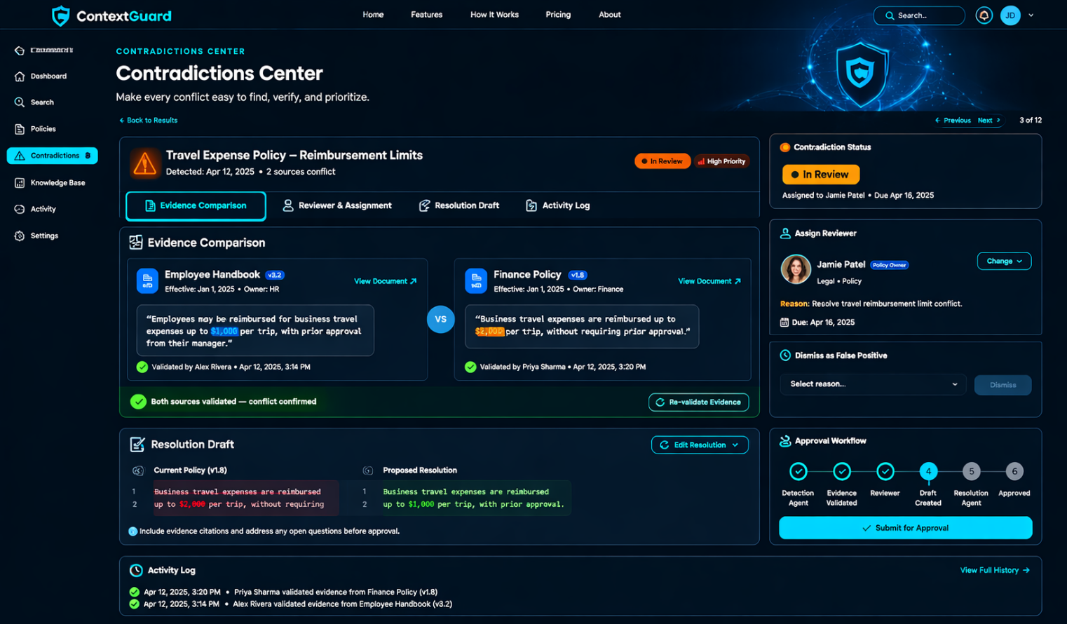
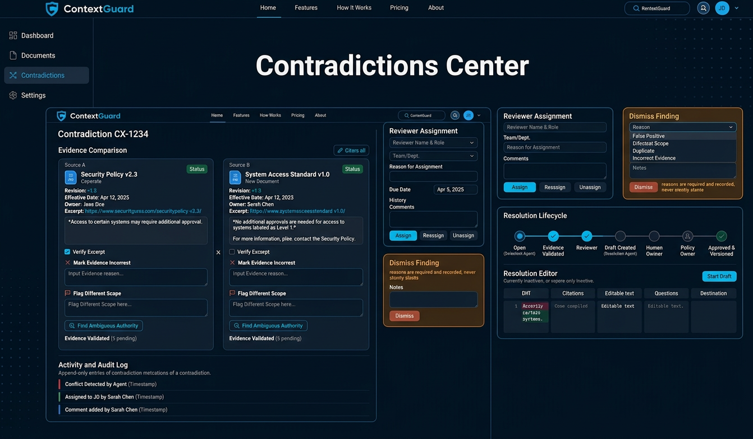
Route: /contradictions
Purpose: Make every conflict easy to find, verify, and prioritize.
The contradiction detail page should be the place where a team member goes from “These documents disagree” to “We've verified the evidence and approved a safe correction.”
I'll follow your reference website's visual style: deep navy, electric-blue primary actions, warm orange warnings, subtle dotted patterns, and clean cards. The page will have four main workflows:
- Validate the evidence.
- Assign a reviewer.
- Dismiss a false positive with a recorded reason.
- Draft, review, and approve a resolution.

1. Page layout
The page uses a fixed sidebar and a flexible content area. On desktop, evidence comparison sits in the main column, with reviewer, status, and activity panels alongside it. On mobile, those panels stack vertically.

Exact interaction rules

A. Evidence validation
Each source should have a dedicated evidence panel showing the document title, revision, effective date, owner, exact excerpt, and a link to the original document.
User action | System response
Open source excerpt | Show the original document at the cited passage
Verify excerpt | Record the reviewer and validation timestamp
Mark evidence incorrect | Require corrected evidence or flag extraction failure
Flag different scope | Request context about teams, regions, or expense types
Validate both sources | Enable the next review action
Find ambiguous authority | Route to a policy owner instead of choosing automatically
Important: Checking a validation box is not proof that a policy is current. The application should separately verify effective dates, document status, and authority metadata.

B. Reviewer assignment
The assignment panel should include:
- Reviewer name and role.
- Team or department.
- Reason for assignment.
- Due date, if applicable.
- Assignment history.
- Optional internal comments.
- Reassign and unassign actions.
When a reviewer is assigned, update the contradiction's status to In Review, record the assignment in the audit log, and notify the reviewer if notifications are configured.

C. Dismissal
A dismissal must never silently delete a finding.
Require a reason, preserve the source evidence, and record who dismissed it and when. If a reviewer later identifies a genuine conflict, an authorized user should be able to reopen it.
Distinguish these outcomes:
- False positive: The statements do not actually conflict.
- Different scope: Both statements are valid in different contexts.
- Duplicate: Another finding already tracks the same issue.
- Incorrect evidence: The extracted source text is inaccurate.
This feedback can later improve ContextGuard's detection quality.

D. Resolution drafting and approval
Use the following lifecycle:
Open contradiction
Detection agent
Evidence validated
Reviewer
Draft created
Resolution agent
Human review
Policy owner
Approved and versioned
Versioning and audit log
The resolution editor should provide a side-by-side diff, evidence citations, editable text, unresolved questions, and the proposed publication destination.
Approval should create a new document version, preserve the previous version, log the approver, and trigger re-analysis of affected documents. If authority is unclear, the system must request a decision rather than publish an AI-selected policy.

4. Recommended implementation for your MVP
Build these interactions against real stored records in Supabase, rather than relying on local UI state.
Feature | Suggested implementation
Evidence validation | evidence_validations table
Reviewer assignment | assigned_to and assigned_at fields on contradictions
Dismissal | dismissal_reason, dismissal_notes, dismissed_by, dismissed_at
Resolution drafts | Separate resolution_drafts table
Approval and versioning | document_versions table
Audit history | Append-only audit_events table
Status tracking | Controlled status values with server-side validation
Use authenticated server-side actions for all state changes. Validate permissions before allowing approval, dismissal, or publication; the frontend alone must not be trusted to enforce access.
Build priority: Evidence validation → reviewer assignment → resolution drafting → approval and versioning → dismissal and reopening.
This gives ContextGuard a complete, demonstrable review workflow while preserving the core promise: AI finds and explains the conflict, but people remain in control of company policy.
Page 4 — Resolution Center
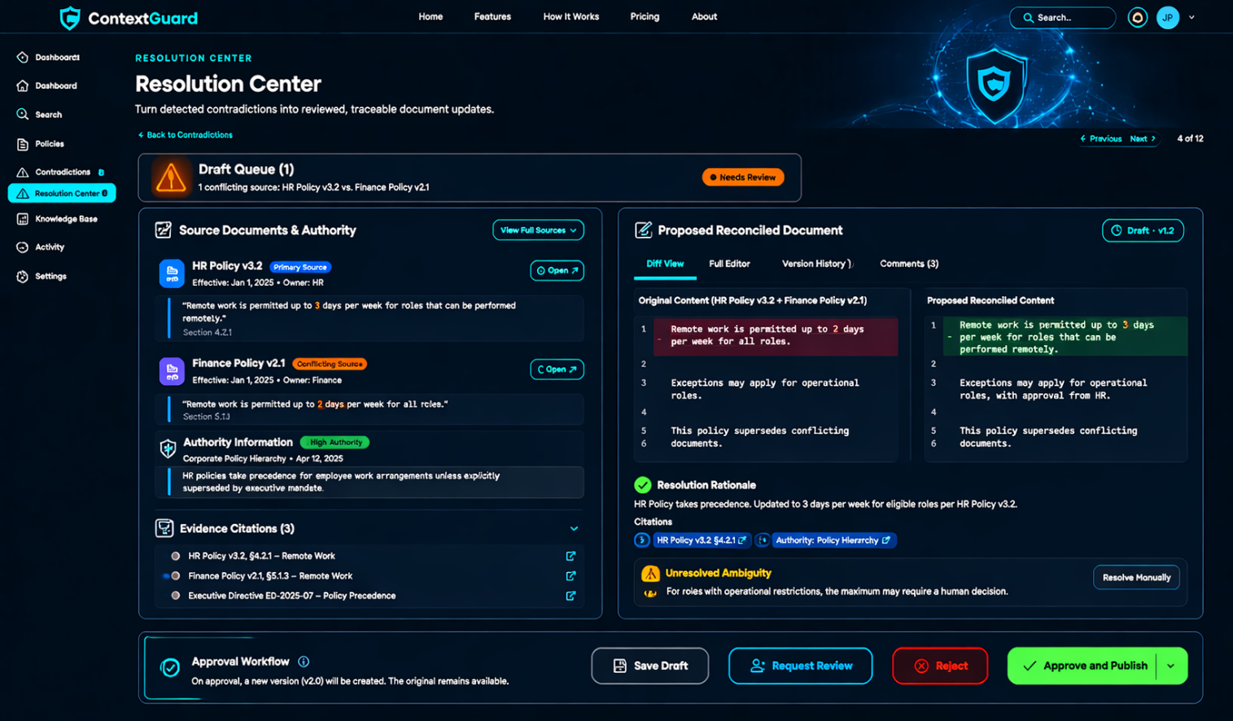
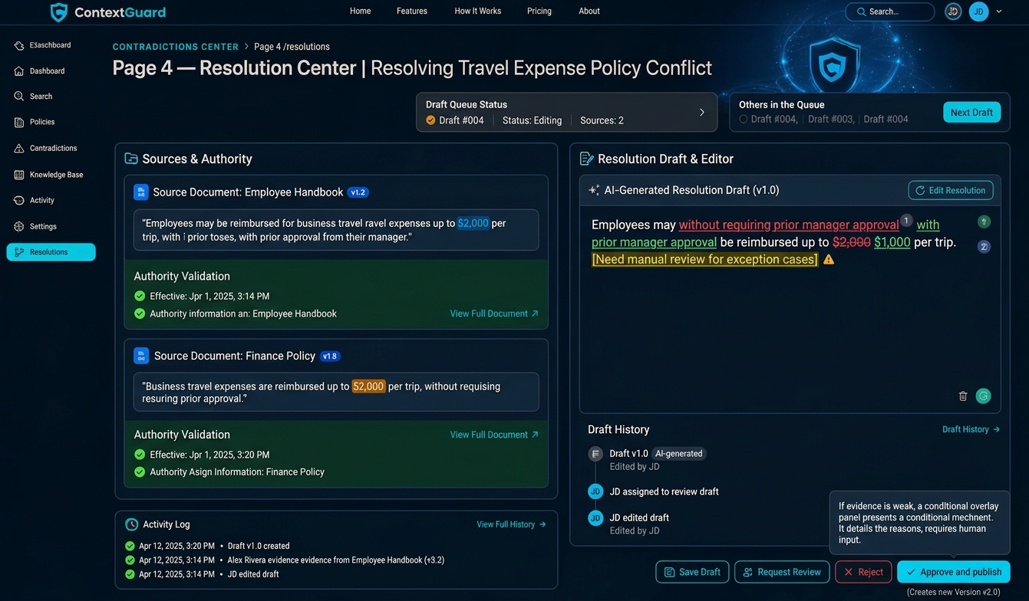
Route: /resolutions
Purpose: Turn detected contradictions into reviewed, traceable document updates.

Features
- Draft queue with status and source conflict.
- AI-generated reconciled documents.
- Side-by-side before/after comparison.
- Inline diff highlighting additions, removals, and edits.
- Evidence citations beside proposed changes.
- Authority and effective-date validation.
- Editable draft content.
- Reviewer assignment and comments.
- Approve, reject, and request-revision actions.
- Version creation on approval.
- Audit trail showing who approved what and when.
- Rollback to a prior version.
- Re-analysis after a document changes.
- Unresolved-ambiguity warnings.
- Draft history and duplicate-resolution prevention.

Resolution editor layout
Use a two-column desktop layout:
- Left panel: source documents, excerpts, and authority information.
- Right panel: proposed reconciled document, editable content, and diff.
- Bottom action bar: Save draft, Request review, Reject, Approve and publish.
On approval, create a new version rather than destroying the original. If the evidence doesn't establish which rule wins, require a human to resolve that question.

Page 5 — Slack Monitor
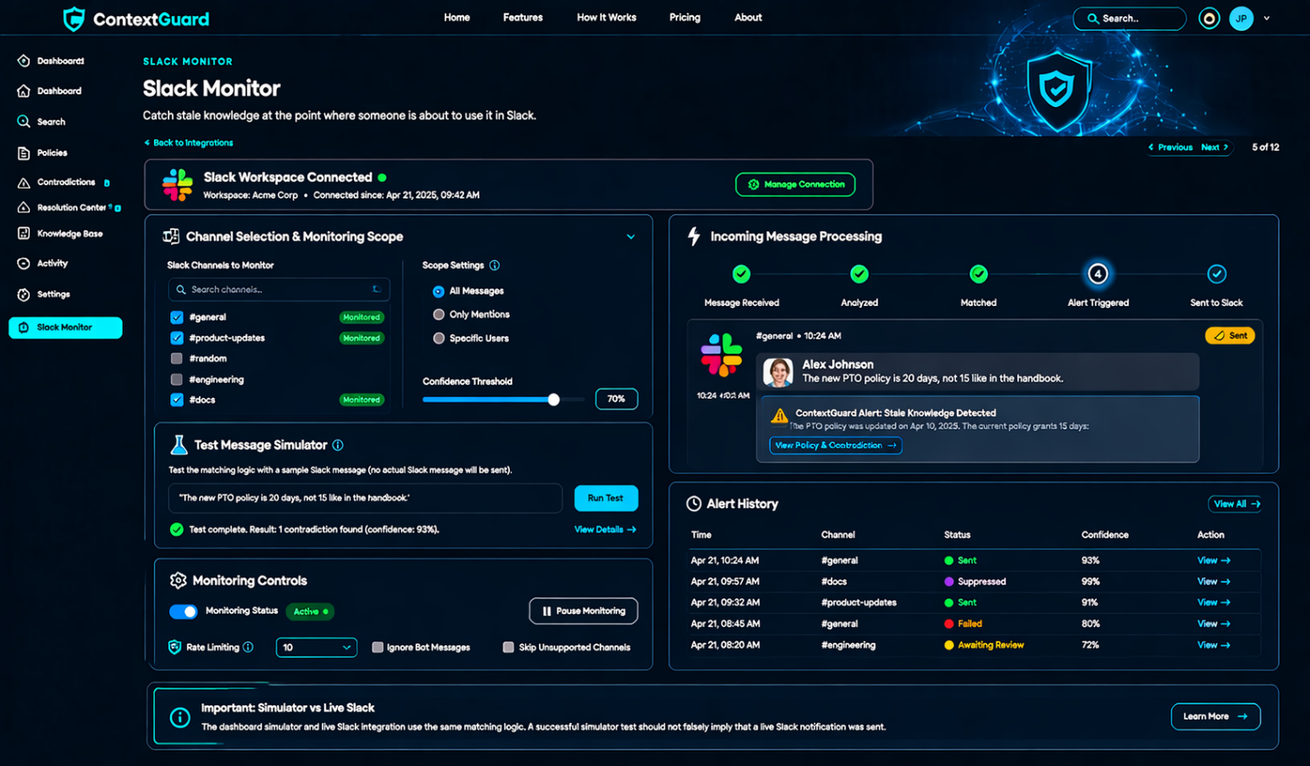
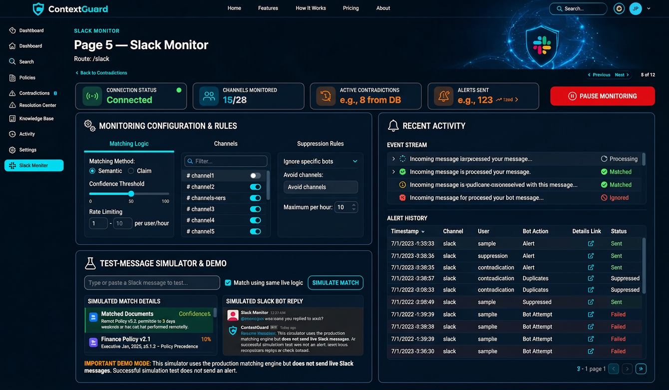
Route: /slack
Purpose: Show how ContextGuard catches stale knowledge at the point where someone is about to use it

Features
- Slack workspace connection status.
- Channel selection and monitoring scope.
- Incoming message event processing.
- Semantic or claim-based matching against known contradictions.
- Confidence thresholds for triggering alerts.
- Threaded bot replies with policy evidence.
- Direct links to affected documents and contradiction details.
- Alert history with timestamps and channel information.
- Duplicate-alert suppression.
- Ignore bot messages and avoid processing unsupported channels.
- Test-message simulator for demos and debugging.
- Per-alert status: sent, suppressed, failed, or awaiting review.
- Alert rate limiting to avoid flooding conversations.
- Admin controls to pause monitoring.
Important UX decision: The dashboard simulator and live Slack integration must use the same matching logic. A successful simulator test should not falsely imply that a live Slack notification was sent.

Page 6 — Analytics

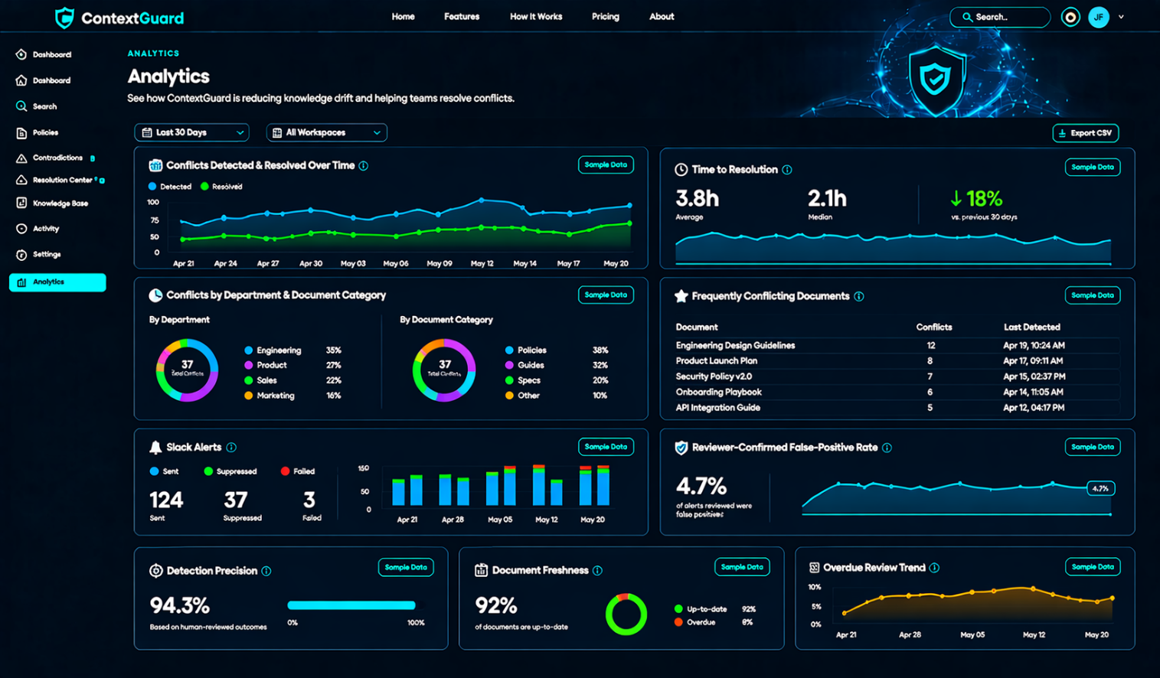
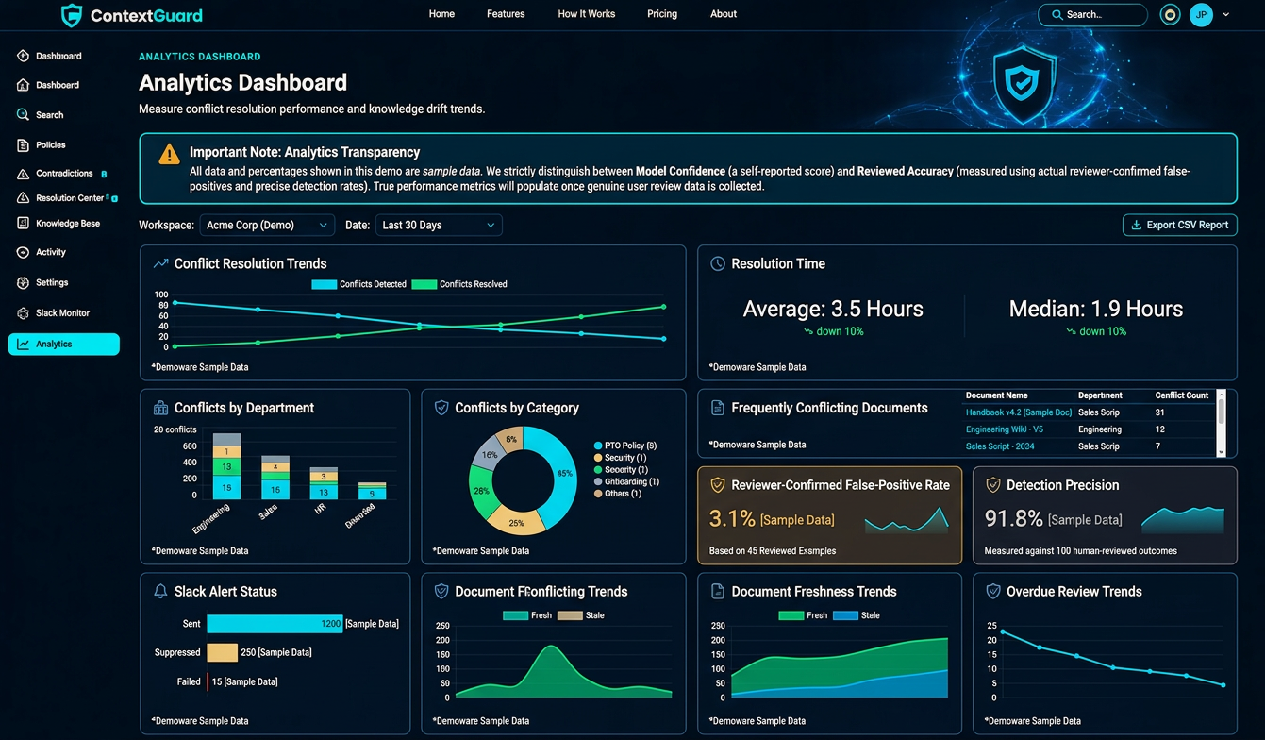

Route: /analytics
Purpose: Show whether ContextGuard is reducing knowledge drift and helping teams resolve conflicts.

Features
- Conflicts detected and resolved over time.
- Average and median time to resolution.
- Conflicts by department and document category.
- Frequently conflicting documents.
- Slack alerts sent, suppressed, and failed.
- Reviewer-confirmed false-positive rate.
- Detection precision based on human-reviewed outcomes.
- Document freshness and overdue-review trends.
- Exportable CSV reports.
- Date filters and workspace filters.
Do not label a model's self-reported confidence as accuracy. Accuracy should be measured using reviewed examples, and all demo analytics should be clearly labeled as sample data until genuine results exist.

Page 7 — Settings

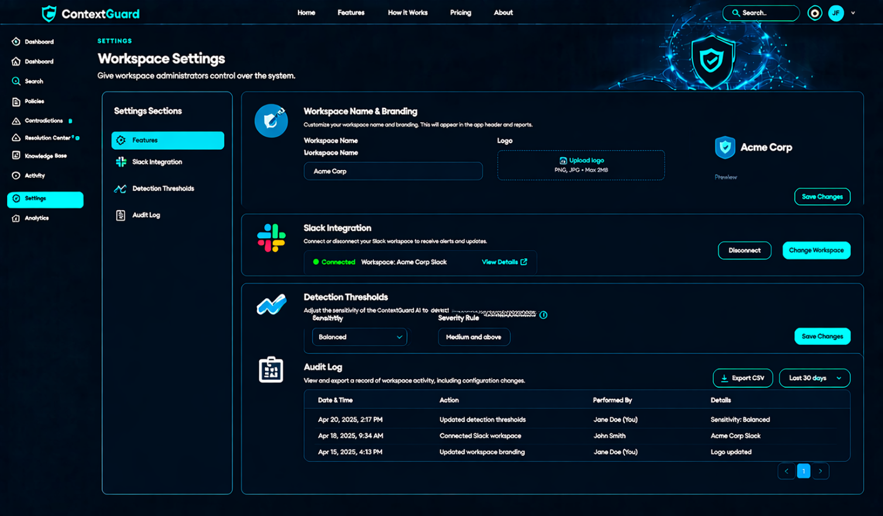
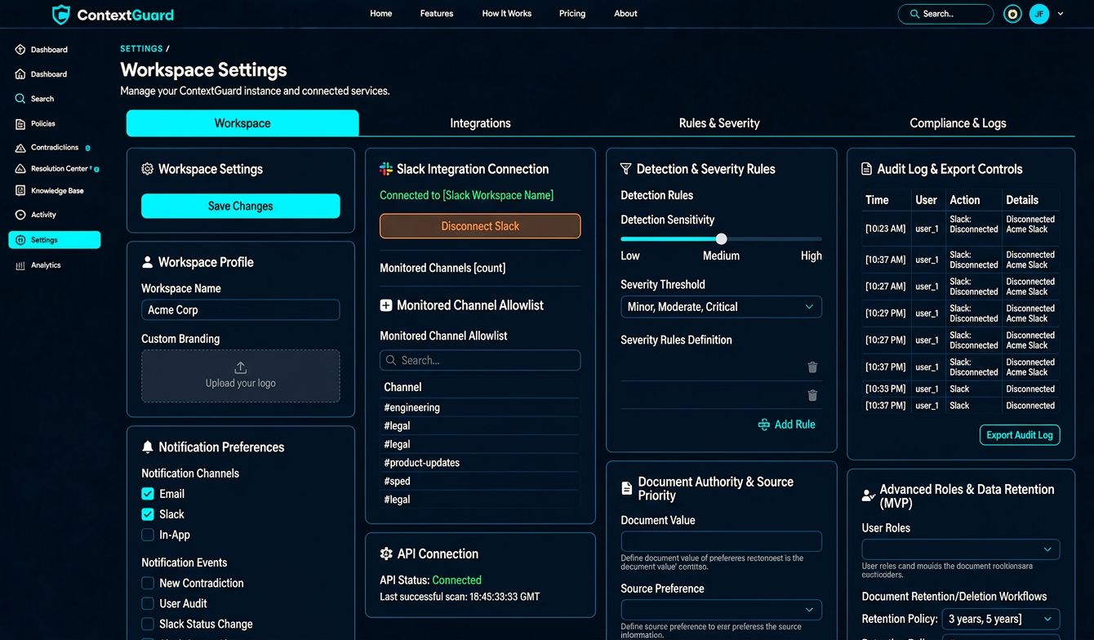
Route: /settings
Purpose: Give workspace administrators control over the system.
Use a settings sub-navigation with these sections:

Features
- Workspace name and branding.
- Slack integration connection and disconnection.
- Monitored-channel allowlist.
- Detection sensitivity and severity rules.
- Configurable document authority and source priority.
- Reviewer and administrator roles.
- Notification preferences.
- Audit log and export controls.
- Document retention and deletion workflows.
- API connection status and last successful scan.
For the MVP, implement basic workspace settings, Slack configuration, detection thresholds, and audit logging. Advanced user management and enterprise controls can come later.

Additional pages and states
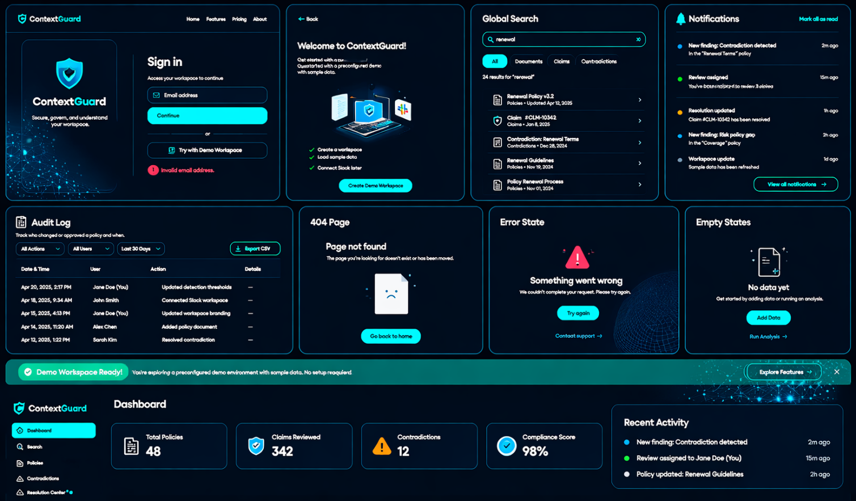
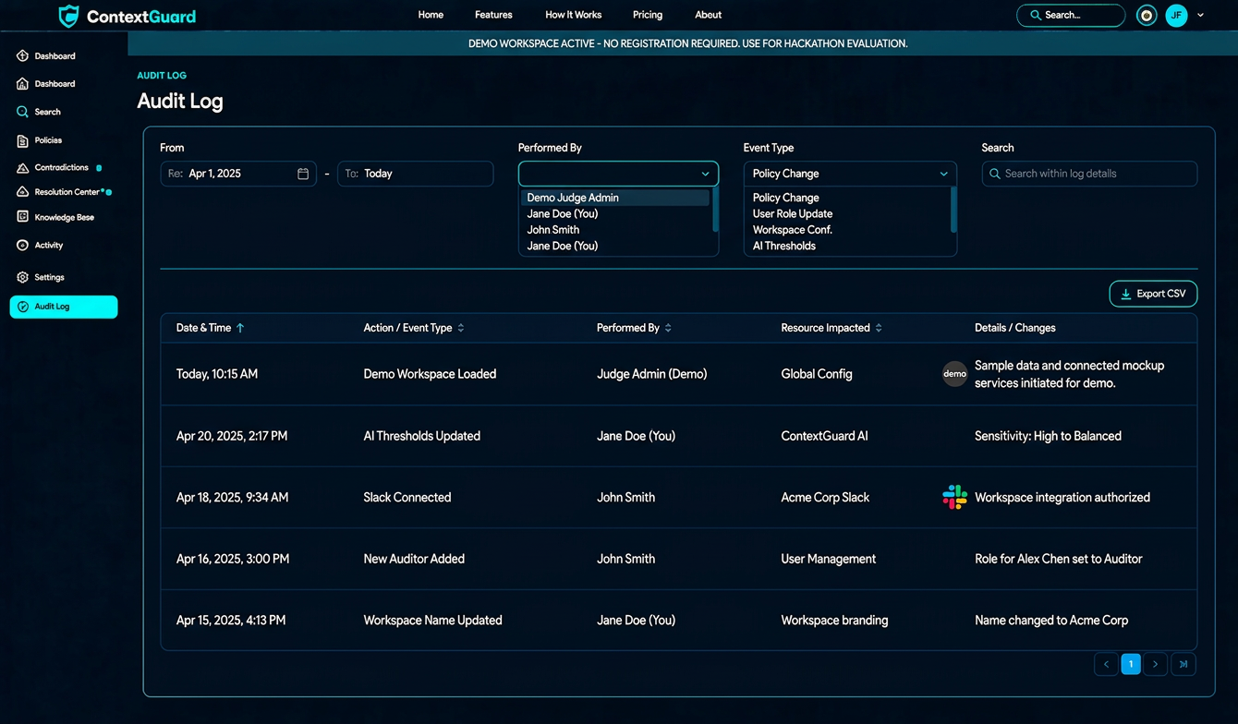

These are smaller pages that make the website feel complete.
Page or state | Route | Required features
Sign in | /login | Email login, error handling, demo access
Onboarding | /onboarding | Create workspace, load sample data, connect Slack later
Global search | /search | Search documents, claims, and contradictions
Notifications | /notifications | New findings, assigned reviews, resolution updates
Audit log | /audit-log | Who changed or approved a policy and when
404 page | Any unknown route | Helpful message and navigation back
Error state | Across the app | Retry actions, readable error messages
Empty states | All data pages | Clear instructions for adding data or running analysis

13. Best implementation order
Build in this sequence to avoid creating a beautiful UI with no working product behind it.
01
Navigation and dashboard
Set up the layout, sidebar, page routing, and sample metrics.
02
Documents library
Implement document creation, editing, search, and metadata.
03
Contradiction detection
Add the three seeded conflicts, evidence comparison, and review statuses.
04
Resolution Center
Generate drafts, compare versions, and approve changes.
05
Slack Monitor
Build the simulator first, then connect real Slack events.
06
Persistence and safeguards
Use Supabase, validate AI outputs, and record audit events.
07
Analytics and Settings
Connect metrics to real records and implement basic configuration.
08
Deployment and demo
Deploy, test the full flow, and rehearse the presentation.
My recommendation: Make the dashboard, document library, contradiction details, resolution editor, and Slack Monitor feel like one connected product. These are the five screens that tell the entire ContextGuard story. The remaining pages should support that workflow rather than distract from it.

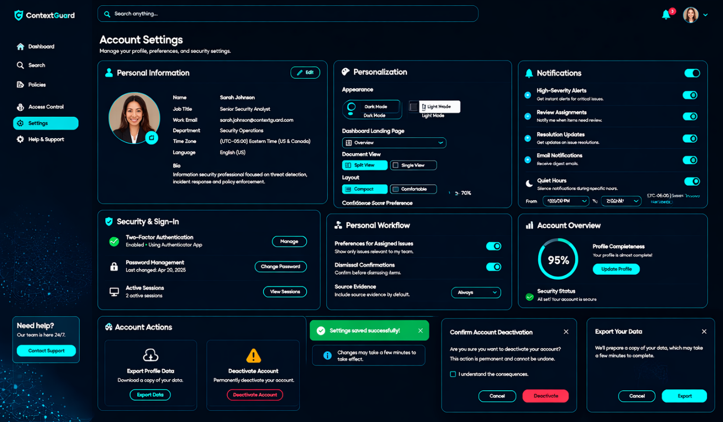

- Personal information: name, job title, work email, department, time zone, language, and bio.
- Personalization: dark/light appearance, dashboard landing page, document view, compact layout, and confidence-score preferences.
- Notifications: high-severity alerts, review assignments, resolution updates, email notifications, and quiet hours.
- Security & sign-in: two-factor authentication setup, password management, and active sessions.
- Personal workflow: preferences for assigned issues, dismissal confirmations, and source evidence.
- Account overview: profile completeness and security status.
- Account actions: profile data export and an account deactivation confirmation.
The page has responsive layouts and interactive controls, including profile editing, preference toggles, validation, and confirmation dialogs.

